Lab-04

Consider any code and draw its CFG by defining its paths and checking the whole code by white box testing.

Code to check whether a number is palindrome or not?

# **Code:**

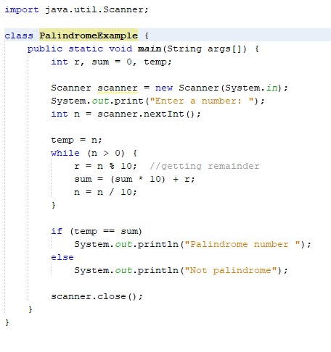

# **Control Flow Graph:**

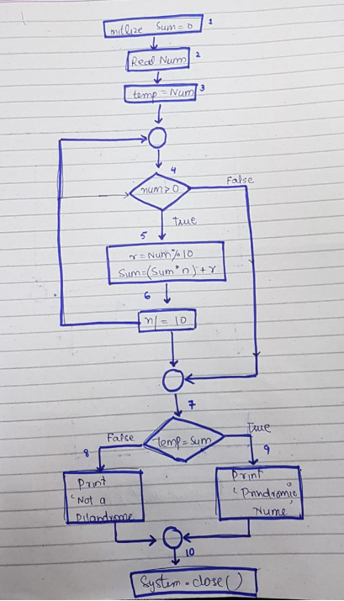

# **Paths:**

**Path 1:** 1 2 3 4(T) 5 6 7(T) 9 10

**Path 2:** 1 2 3 4(T) 5 6 7(F) 8 10

**Path 3:** 1 2 3 4(F) 7(T) 9 10

**Path 4:** 1 2 3 4(F) 7(F) 8 10

# **Test cases**

|  |  |  |  |  |  |
| --- | --- | --- | --- | --- | --- |
| **Test ID** | **Test Case Description** | **Input Data** | **Actual** | **Expected** | **Verdict** |
| 1 | Palindrome number | 12321 | Palindrome number | Palindrome number | Pass |
| 2 | Non-palindrome number | 12345 | Not palindrome | Not palindrome | Pass |
| 3 | Single-digit palindrome | 7 | Palindrome number | Palindrome number | Pass |
| 4 | Negative palindrome number | -121 | Palindrome number | Not palindrome | Fail |
| 5 | Large palindrome number | 1234560654321 | Palindrome number | Palindrome number | Pass |
| 6 | Zero | 0 | Palindrome number | Palindrome number | Pass |